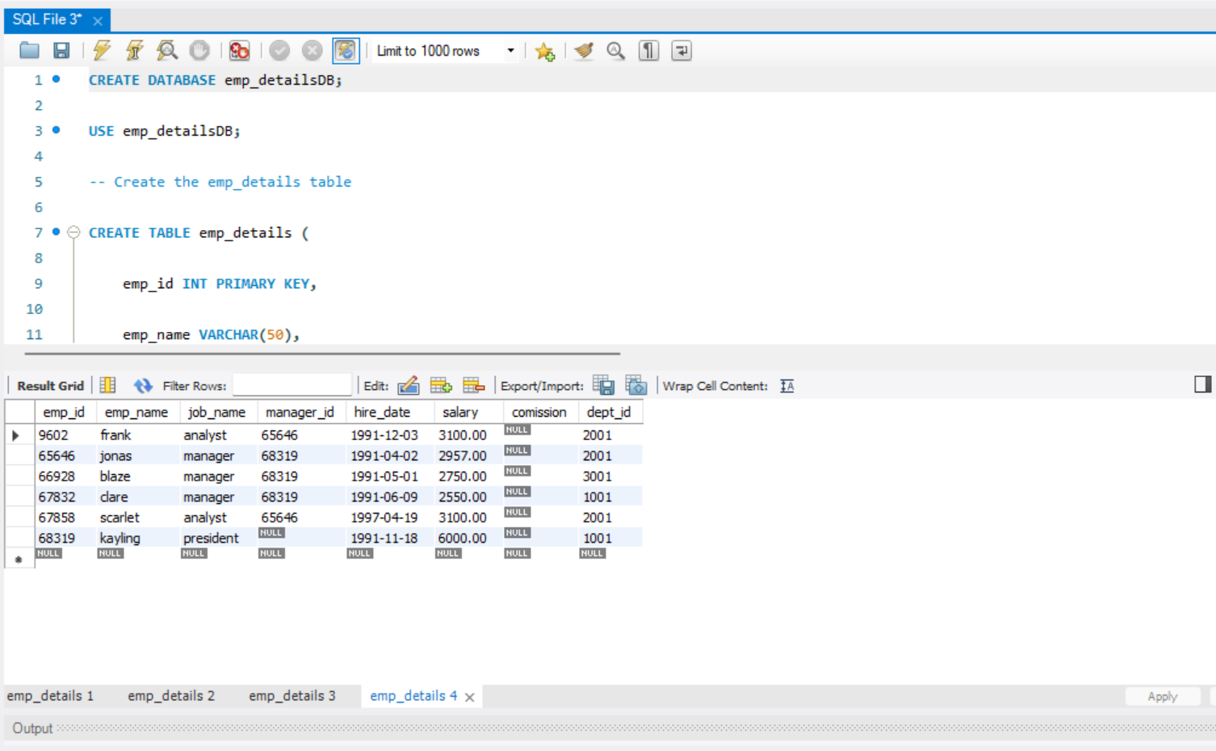

CREATE DATABASE emp_detailsDB;

USE emp_detailsDB;

-- Create the emp_details table

CREATE TABLE emp_details (

emp_id INT PRIMARY KEY,

emp_name VARCHAR(50),

job_name VARCHAR(50),

manager_id INT,

hire_date DATE,

salary DECIMAL(10, 2),

comission DECIMAL(10, 2),

dept_id INT

);

-- Insert the records

INSERT INTO emp_details (emp_id, emp_name, job_name, manager_id, hire_date, salary, comission, dept_id)

VALUES

(68319, 'kayling', 'president', NULL, '1991-11-18', 6000.00, NULL, 1001),

(66928, 'blaze', 'manager', 68319, '1991-05-01', 2750.00, NULL, 3001),

(67832, 'clare', 'manager', 68319, '1991-06-09', 2550.00, NULL, 1001),

(65646, 'jonas', 'manager', 68319, '1991-04-02', 2957.00, NULL, 2001),

(67858, 'scarlet', 'analyst', 65646, '1997-04-19', 3100.00, NULL, 2001),

(9602, 'frank', 'analyst', 65646, '1991-12-03', 3100.00, NULL, 2001);

-- Select all records with salary between 2500 and 3500

SELECT *

FROM emp_details

WHERE salary BETWEEN 2500 AND 3500;

-- Select all records with salary starting from digit 2 (use LIKE operator)

SELECT *

FROM emp_details

WHERE salary LIKE '2%';

-- Select all records with salary having digit 2 or 3 in between (use LIKE operator)

SELECT *

FROM emp_details

WHERE salary LIKE '%2%' OR salary LIKE '%3%';

-- Select all records having 0 in salary at the last position (use LIKE operator)

SELECT *

FROM emp_details

WHERE salary LIKE '%0';